모바일프로그래밍 과제12 컴퓨터소프트웨어공학과 2-YA 20202296 전채린

실습 11-1, 11-2 XML을 이용한 리스트뷰 만들기

[소스코드]

activity_main.xml

<?xml version="1.0" encoding="utf-8"?>  
<LinearLayout xmlns:android="http://schemas.android.com/apk/res/android"  
 xmlns:app="http://schemas.android.com/apk/res-auto"  
 xmlns:tools="http://schemas.android.com/tools"  
 android:layout_width="match_parent"  
 android:layout_height="match_parent"  
 android:orientation="vertical"  
 tools:context=".MainActivity">  
  
 /* 02 리스트뷰  
 예제11-1 리스트뷰 기본 예제의 XML 코드 */  
 <TextView  
 android:layout_width="match_parent"  
 android:layout_height="wrap_content"  
 android:text="20202296 전채린" />  
 <ListView  
 android:layout_width="match_parent"  
 android:layout_height="wrap_content"  
 android:id="@+id/listView1" />  
</LinearLayout>

MainActivity.kt

package aca.hankook.ex11_1  
  
import androidx.appcompat.app.AppCompatActivity  
import android.os.Bundle  
import android.widget.ArrayAdapter  
import android.widget.Toast  
import kotlinx.android.synthetic.main.activity_main.*  
  
class MainActivity : AppCompatActivity() {  
  
 override fun onCreate(savedInstanceState: Bundle?) {  
 super.onCreate(savedInstanceState)  
 setContentView(R.layout.*activity_main*)  
  
 /* 02 리스트뷰  
 예제11-2 리스트뷰 기본 예제의 Kotlin 코드 */  
 *title* = "리스트뷰 테스트"  
  
 var mid = *arrayOf*("히어로즈", "24시", "로스트", "로스트룸", "스몰빌", "탐정몽크", "빅뱅이론", "프렌즈", "덱스터", "클리", "가쉽걸", "테이큰", "슈퍼내추럴", "브이")  
  
 var adapter1 : ArrayAdapter<String> = ArrayAdapter(this, android.R.layout.*simple_list_item_1*, mid)  
 listView1.*adapter* = adapter1  
 listView1.setOnItemClickListener **{** adapterView, view, i, l **->** Toast.makeText(*applicationContext*, mid[i], Toast.*LENGTH_LONG*).show()  
 **}** }  
}

[실행결과]

1) 초기화면

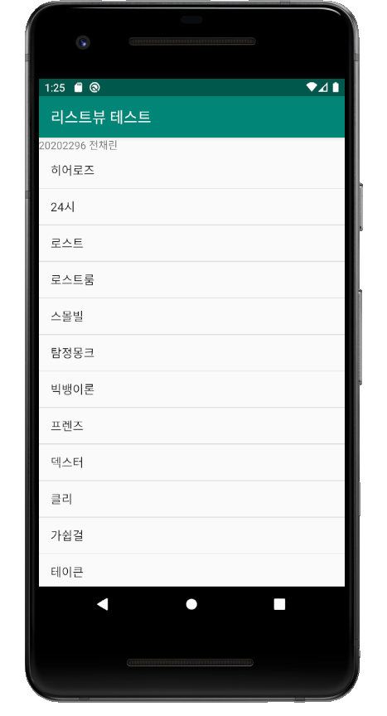

2) 히어로즈 선택 화면

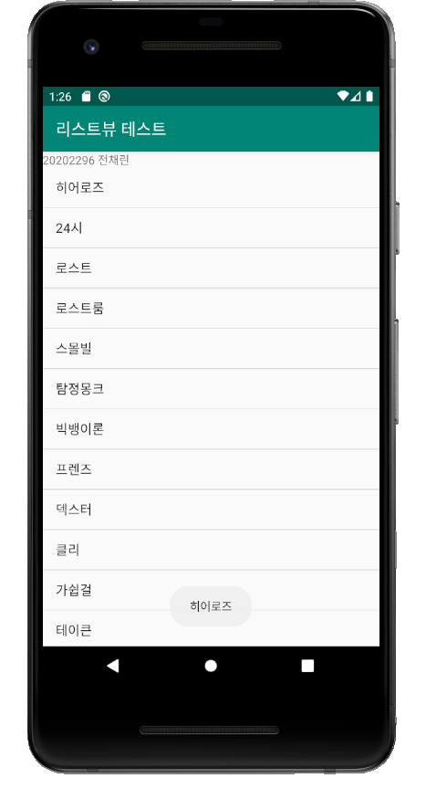

실습 11-3 리스트뷰의 다양한 모양 설정

[소스코드]

activity_main.xml

<?xml version="1.0" encoding="utf-8"?>  
<LinearLayout xmlns:android="http://schemas.android.com/apk/res/android"  
 xmlns:app="http://schemas.android.com/apk/res-auto"  
 xmlns:tools="http://schemas.android.com/tools"  
 android:layout_width="match_parent"  
 android:layout_height="match_parent"  
 android:orientation="vertical"  
 tools:context=".MainActivity">  
  
 /* 02 리스트뷰  
 예제11-1 리스트뷰 기본 예제의 XML 코드 */  
 <TextView  
 android:layout_width="match_parent"  
 android:layout_height="wrap_content"  
 android:text="20202296 전채린" />  
 <ListView  
 android:layout_width="match_parent"  
 android:layout_height="wrap_content"  
 android:id="@+id/listView1" />  
</LinearLayout>

MainActivity.kt

package aca.hankook.ex11_3  
  
import androidx.appcompat.app.AppCompatActivity  
import android.os.Bundle  
import android.widget.ArrayAdapter  
import android.widget.ListView  
import android.widget.Toast  
import kotlinx.android.synthetic.main.activity_main.*  
  
class MainActivity : AppCompatActivity() {  
  
 override fun onCreate(savedInstanceState: Bundle?) {  
 super.onCreate(savedInstanceState)  
 setContentView(R.layout.*activity_main*)  
  
 /* 02 리스트뷰  
 예제11-3 모양을 변경한 리스트뷰의 Kotlin 코드 */  
 *title* = "리스트뷰 테스트"  
  
 var mid = *arrayOf*("히어로즈", "24시", "로스트", "로스트룸", "스몰빌", "탐정몽크", "빅뱅이론", "프렌즈", "덱스터", "클리", "가쉽걸", "테이큰", "슈퍼내추럴", "브이")  
  
 var adapter1 : ArrayAdapter<String> = ArrayAdapter(this, android.R.layout.*simple_list_item_multiple_choice*, mid)  
 listView1.*choiceMode* = ListView.*CHOICE_MODE_MULTIPLE* listView1.*adapter* = adapter1  
 listView1.setOnItemClickListener **{** adapterView, view, i, l **->** Toast.makeText(*applicationContext*, mid[i], Toast.*LENGTH_LONG*).show()  
 **}** }  
}

[실행결과]

1) 첫 번째 화면

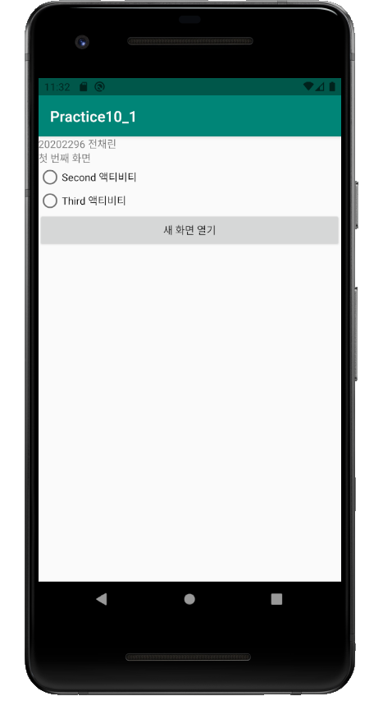

예제 11-4, 11-5 리스트뷰의 동적 추가∙삭제

[소스코드]

activity_main.xml

<?xml version="1.0" encoding="utf-8"?>  
<LinearLayout xmlns:android="http://schemas.android.com/apk/res/android"  
 xmlns:app="http://schemas.android.com/apk/res-auto"  
 xmlns:tools="http://schemas.android.com/tools"  
 android:layout_width="match_parent"  
 android:layout_height="match_parent"  
 android:orientation="vertical"  
 tools:context=".MainActivity">  
  
 /* 02 리스트뷰  
 예제11-4 동적인 리스트뷰 항목 추가, 삭제의 XML 코드 */  
 <TextView  
 android:layout_width="match_parent"  
 android:layout_height="wrap_content"  
 android:text="20202296 전채린" />  
 <EditText  
 android:layout_width="match_parent"  
 android:layout_height="wrap_content"  
 android:id="@+id/editItem" />  
 <Button  
 android:layout_width="match_parent"  
 android:layout_height="wrap_content"  
 android:id="@+id/btnAdd"  
 android:text="항목 추가" />  
 <ListView  
 android:layout_width="match_parent"  
 android:layout_height="wrap_content"  
 android:id="@+id/listView1" />  
</LinearLayout>

MainActivity.kt

package aca.hankook.ex11_4  
  
import androidx.appcompat.app.AppCompatActivity  
import android.os.Bundle  
import android.widget.ArrayAdapter  
import kotlinx.android.synthetic.main.activity_main.*  
  
class MainActivity : AppCompatActivity() {  
  
 override fun onCreate(savedInstanceState: Bundle?) {  
 super.onCreate(savedInstanceState)  
 setContentView(R.layout.*activity_main*)  
  
 /* 02 리스트뷰  
 예제11-5 동적인 리스트뷰 항목 추가, 삭제의 Kotlin 코드 */  
 var midList = ArrayList<String>()  
  
 var adapter1 = ArrayAdapter(this, android.R.layout.*simple_list_item_1*, midList)  
 listView1.*adapter* = adapter1  
  
 btnAdd.setOnClickListener **{** midList.add(editItem.*text*.toString())  
 adapter1.notifyDataSetChanged()  
 **}** listView1.setOnItemLongClickListener **{** adapterView, view, i, l **->** midList.removeAt(i)  
 adapter1.notifyDataSetChanged()  
 false  
 **}** }  
}

[실행결과]

1) 초기화면

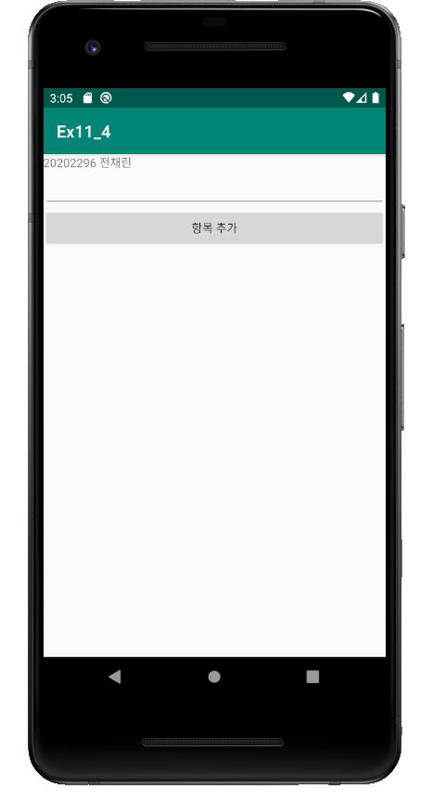

2) 리스트뷰 추가 화면

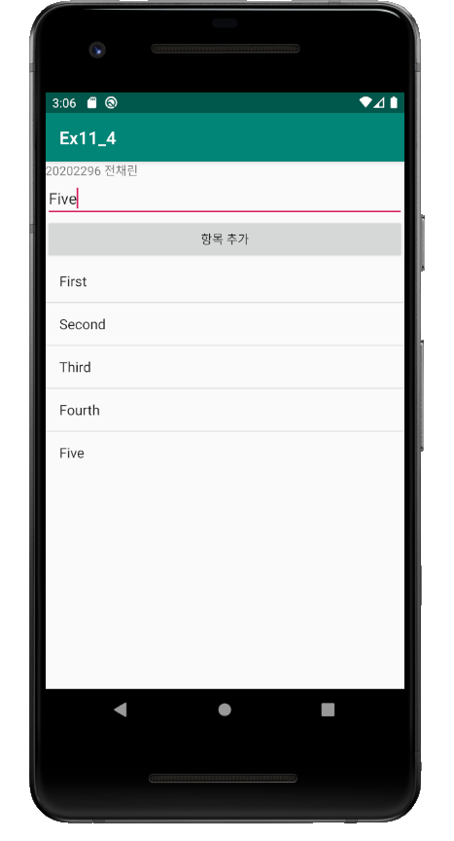

3) 리스트뷰 삭제 화면

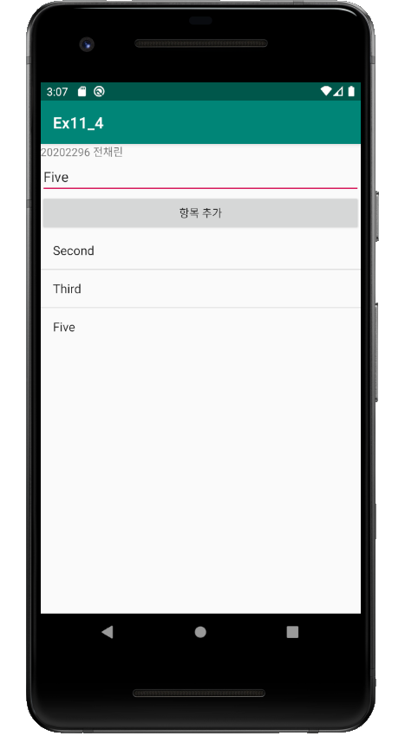

실습 11-1 영화 포스터 보기 1

[소스코드]

activity_main.xml

<?xml version="1.0" encoding="utf-8"?>  
<LinearLayout xmlns:android="http://schemas.android.com/apk/res/android"  
 xmlns:app="http://schemas.android.com/apk/res-auto"  
 xmlns:tools="http://schemas.android.com/tools"  
 android:layout_width="match_parent"  
 android:layout_height="match_parent"  
 android:orientation="vertical"  
 tools:context=".MainActivity">  
  
 /* 03 그리드뷰  
 실습11-1 영화 포스터 보기 1 */  
 /* 그리드뷰를 이용하여 여러 사진(영화 포스터)을 격자 모양으로 배치  
 영화 포스터를 클릭하면 확대된 포스터가 대화상자로 표시 */  
 /* 예제11-6 activity_main.xml */  
  
 <TextView  
 android:layout_width="match_parent"  
 android:layout_height="wrap_content"  
 android:text="20202296 전채린" />  
 <GridView  
 android:layout_width="match_parent"  
 android:layout_height="wrap_content"  
 android:id="@+id/gridView1"  
 android:gravity="center"  
 android:numColumns="4" />  
</LinearLayout>

dialog.xml

<?xml version="1.0" encoding="utf-8"?>  
<LinearLayout xmlns:android="http://schemas.android.com/apk/res/android"  
 android:orientation="vertical" android:layout_width="match_parent"  
 android:layout_height="match_parent"  
 android:gravity="center">  
  
 /* 03 그리드뷰  
 예제11-7 dialog.xml */  
  
 <ImageView  
 android:layout_width="match_parent"  
 android:layout_height="wrap_content"  
 android:id="@+id/ivPoster" />  
</LinearLayout>

MainActivity.kt

package aca.hankook.project11_1  
  
import android.content.Context  
import androidx.appcompat.app.AppCompatActivity  
import android.os.Bundle  
import android.view.View  
import android.view.ViewGroup  
import android.widget.BaseAdapter  
import android.widget.ImageView  
import androidx.appcompat.app.AlertDialog  
import kotlinx.android.synthetic.main.activity_main.*  
import kotlinx.android.synthetic.main.dialog.*  
import kotlinx.android.synthetic.main.dialog.view.*  
  
class MainActivity : AppCompatActivity() {  
 override fun onCreate(savedInstanceState: Bundle?) {  
 super.onCreate(savedInstanceState)  
 setContentView(R.layout.*activity_main*)  
  
 /* 03 그리드뷰  
 예제11-8 메인 액티비티의 Kotlin 코드 1 */  
 *title* = "그리드뷰 영화 포스터"  
  
 var gAdapter = MyGridAdapter(this)  
 gridView1.*adapter* = gAdapter  
 }  
  
 inner class MyGridAdapter(var context: Context) : BaseAdapter() {  
 /* 03 그리드뷰  
 예제11-9 메인 액티비티의 Kotlin 코드 2 */  
 var posterID = *arrayOf*(  
 R.drawable.*mov01*, R.drawable.*mov02*, R.drawable.*mov03*, R.drawable.*mov04*,  
 R.drawable.*mov05*, R.drawable.*mov06*, R.drawable.*mov07*, R.drawable.*mov08*,  
 R.drawable.*mov09*, R.drawable.*mov10*,  
 R.drawable.*mov01*, R.drawable.*mov02*, R.drawable.*mov03*, R.drawable.*mov04*,  
 R.drawable.*mov05*, R.drawable.*mov06*, R.drawable.*mov07*, R.drawable.*mov08*,  
 R.drawable.*mov09*, R.drawable.*mov10*,  
 R.drawable.*mov01*, R.drawable.*mov02*, R.drawable.*mov03*, R.drawable.*mov04*,  
 R.drawable.*mov05*, R.drawable.*mov06*, R.drawable.*mov07*, R.drawable.*mov08*,  
 R.drawable.*mov09*, R.drawable.*mov10* )  
  
 var posterTitle = *arrayOf*("써니", "완득이", "괴물", "라디오스타", "비열한거리", "왕의남자", "아일랜드", "웰컴투동막골", "헬보이", "빽투더퓨처")  
  
 /* 03 그리드뷰  
 예제11-10 메인 액티비티의 Kotlin 코드 3 */  
 override fun getView(p0: Int, p1: View?, p2: ViewGroup?) : View {  
 var imageView1 = ImageView(context)  
 imageView1.*layoutParams* = ViewGroup.LayoutParams(200, 300)  
 imageView1.*scaleType* = ImageView.ScaleType.FIT_CENTER  
 imageView1.setPadding(5, 5, 5, 5)  
  
 imageView1.setImageResource(posterID[p0])  
  
 /* 03 그리드뷰  
 예제11-11 메인 액티비티의 Kotlin 코드 4 */  
 imageView1.setOnClickListener **{** var dialogView1 = View.inflate(this@MainActivity, R.layout.*dialog*, null)  
 var dlg = AlertDialog.Builder(this@MainActivity)  
 // 대화상자를 클릭했을 때 보여주는 그림  
 dialogView1.ivPoster.setImageResource(posterID[p0])  
 dlg.setTitle(posterTitle[p0])  
 dlg.setIcon(R.drawable.*ic_launcher_foreground*)  
 dlg.setView(dialogView1)  
 dlg.setNegativeButton("닫기", null)  
 dlg.show()  
 **}** return imageView1  
 }  
  
 override fun getItem(p0: Int): Any {  
 return 0  
 }  
  
 override fun getItemId(p0: Int): Long {  
 return 0  
 }  
  
 override fun getCount(): Int {  
 return posterID.size  
 }  
 }  
}

[실행결과]

1) 초기화면

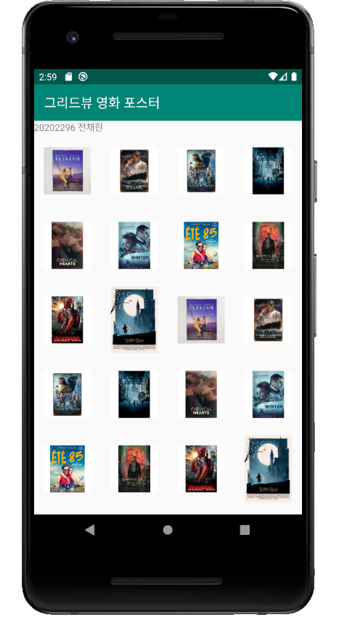

2) 영화 포스터 선택 화면

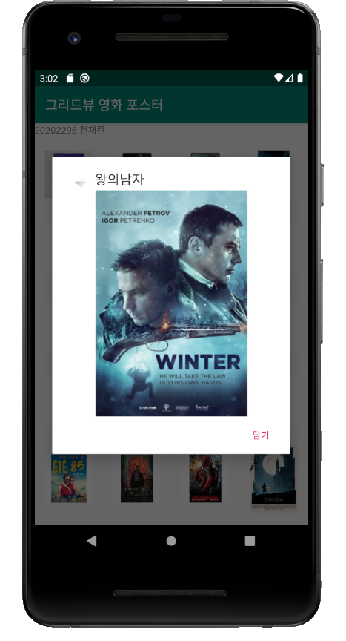

실습 11-2 영화 포스터 보기 2

[소스코드]

activity_main.xml

<?xml version="1.0" encoding="utf-8"?>  
<LinearLayout xmlns:android="http://schemas.android.com/apk/res/android"  
 xmlns:app="http://schemas.android.com/apk/res-auto"  
 xmlns:tools="http://schemas.android.com/tools"  
 android:layout_width="match_parent"  
 android:layout_height="match_parent"  
 android:orientation="vertical"  
 tools:context=".MainActivity">  
  
 /* 01 갤러리  
 실습11-2 영화 포스터 보기 2 */  
 /* [실습11-1]에서는 그리드뷰를 이용하여 작성한 영화 포스터 보기 앱을 이번에는 갤러리를 이용함  
 영화 포스터를 클릭하면 대화상자 대신 아래쪽 이미지뷰에 확대된 영화 포스터가 나옴 */  
 /* 예제11-12 activity_main.xml */  
  
 <TextView  
 android:layout_width="match_parent"  
 android:layout_height="wrap_content"  
 android:text="20202296 전채린" />  
 <Gallery  
 android:layout_width="match_parent"  
 android:layout_height="wrap_content"  
 android:id="@+id/gallery1"  
 android:spacing="5dp" />  
 <ImageView  
 android:layout_width="match_parent"  
 android:layout_height="wrap_content"  
 android:id="@+id/ivPoster"  
 android:padding="20dp" />  
</LinearLayout>

MainActivity.kt

package aca.hankook.project11_2  
  
import android.content.Context  
import androidx.appcompat.app.AppCompatActivity  
import android.os.Bundle  
import android.view.View  
import android.view.ViewGroup  
import android.widget.BaseAdapter  
import android.widget.Gallery  
import android.widget.ImageView  
import kotlinx.android.synthetic.main.activity_main.*  
import java.security.AccessControlContext  
  
class MainActivity : AppCompatActivity() {  
  
 override fun onCreate(savedInstanceState: Bundle?) {  
 super.onCreate(savedInstanceState)  
 setContentView(R.layout.*activity_main*)  
  
 /* 01 갤러리  
 예제11-13 메인 액티비티의 Kotlin 코드 1 */  
 var galAdapter = MyGalleryAdapter(this)  
 gallery1.*adapter* = galAdapter  
 }  
  
 inner class MyGalleryAdapter(var context: Context) : BaseAdapter() {  
 var posterID = *arrayOf*(  
 R.drawable.*mov01*, R.drawable.*mov02*, R.drawable.*mov03*, R.drawable.*mov04*,  
 R.drawable.*mov05*, R.drawable.*mov06*, R.drawable.*mov07*, R.drawable.*mov08*,  
 R.drawable.*mov09*, R.drawable.*mov10* )  
  
 var posterTitle = *arrayOf*("써니", "완득이", "괴물", "라디오스타", "비열한거리", "왕의남자", "아일랜드", "웰컴투동막골", "헬보이", "빽투더퓨처")  
  
 /* 01 갤러리  
 예제11-14 메인 액티비티의 Kotlin 코드 2 */  
 override fun getView(p0: Int, p1: View?, p2: ViewGroup?): View {  
 var imageview = ImageView(context)  
 imageview.*layoutParams* = Gallery.LayoutParams(200, 300)  
 imageview.*scaleType* = ImageView.ScaleType.FIT_CENTER  
 imageview.setPadding(5, 5, 5, 5)  
 imageview.setImageResource(posterID[p0])  
  
 /* 01 갤러리  
 예제11-15 메인 액티비티의 Kotlin 코드 3 */  
 imageview.setOnTouchListener **{** view, motionEvent **->** ivPoster.*scaleType* = ImageView.ScaleType.FIT_CENTER  
 ivPoster.setImageResource(posterID[p0])  
 false  
 **}** return imageview  
 }  
  
 override fun getItem(p0: Int): Any {  
 return 0  
 }  
  
 override fun getItemId(p0: Int): Long {  
 return 0  
 }  
  
 override fun getCount(): Int {  
 return posterID.size  
 }  
  
  
 }  
}

[실행결과]

1) 초기화면

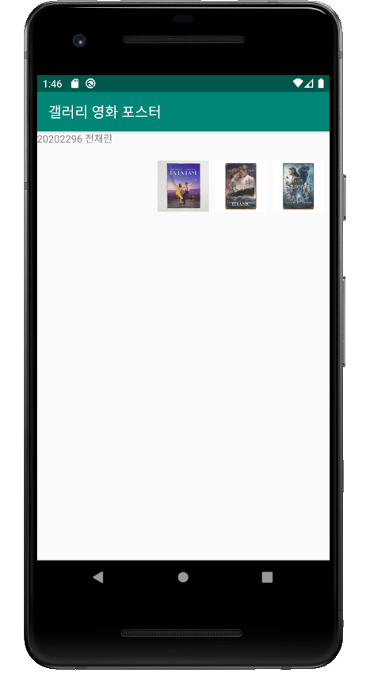

2) 영화 포스터 선택 화면

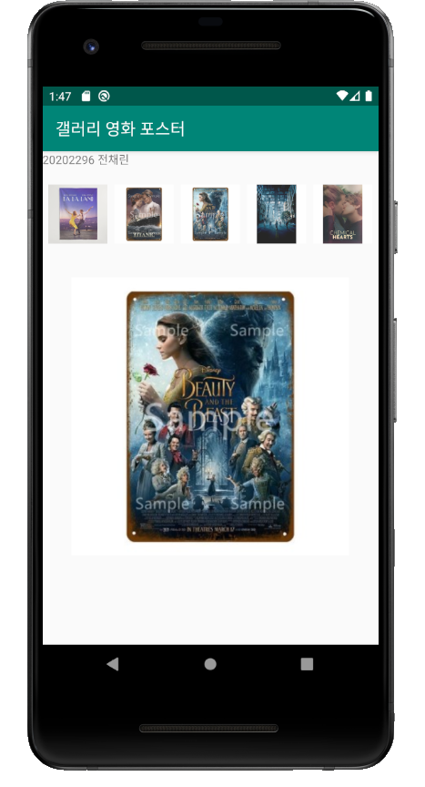

실습 11-16, 11-17 스피너

[소스코드]

activity_main.xml

<?xml version="1.0" encoding="utf-8"?>  
<LinearLayout xmlns:android="http://schemas.android.com/apk/res/android"  
 xmlns:app="http://schemas.android.com/apk/res-auto"  
 xmlns:tools="http://schemas.android.com/tools"  
 android:layout_width="match_parent"  
 android:layout_height="match_parent"  
 android:orientation="vertical"  
 tools:context=".MainActivity">  
  
 /* 01 스피너  
 예제11-16 스피너 기본 예제의 XML 코드 */  
  
 <TextView  
 android:layout_width="match_parent"  
 android:layout_height="wrap_content"  
 android:text="20202296 전채린" />  
 <Spinner  
 android:layout_width="match_parent"  
 android:layout_height="wrap_content"  
 android:id="@+id/spinner1" />  
</LinearLayout>

MainActivity.kt

package aca.hankook.ex11_16  
  
import androidx.appcompat.app.AppCompatActivity  
import android.os.Bundle  
import android.view.View  
import android.widget.AdapterView  
import android.widget.ArrayAdapter  
import android.widget.Toast  
import kotlinx.android.synthetic.main.activity_main.*  
  
class MainActivity : AppCompatActivity() {  
  
 override fun onCreate(savedInstanceState: Bundle?) {  
 super.onCreate(savedInstanceState)  
 setContentView(R.layout.*activity_main*)  
  
 /* 01 스피너  
 예제11-17 스피너 기본 예제의 Kotlin 코드 */  
 *title* = "스피너 테스트"  
  
 var movie = *arrayOf*("쿵푸팬더", "짱구는 못말려","아저씨",  
 "아바타", "대부", "국가대표", "토이스토리3",  
 "마당을 나온 암탉", "죽은 시인의 사회", "서유기")  
  
 var sAdapter1 : ArrayAdapter<String>  
 sAdapter1 = ArrayAdapter(this, android.R.layout.*simple_spinner_item*, movie)  
 spinner1.*adapter* = sAdapter1  
   
 spinner1.*onItemSelectedListener* = object : AdapterView.OnItemSelectedListener {  
 override fun onNothingSelected(p0: AdapterView<*>?) {  
 Toast.makeText(this@MainActivity, "아무것도 선택하지 않았습니다, 선택하세요...", Toast.*LENGTH_LONG*).show()  
 }  
  
 override fun onItemSelected(parent: AdapterView<*>?, view: View?, position: Int, id: Long) {  
 Toast.makeText(this@MainActivity, movie[position], Toast.*LENGTH_LONG*).show()  
 }  
  
 }  
 }  
}

[실행결과]

1) 초기화면

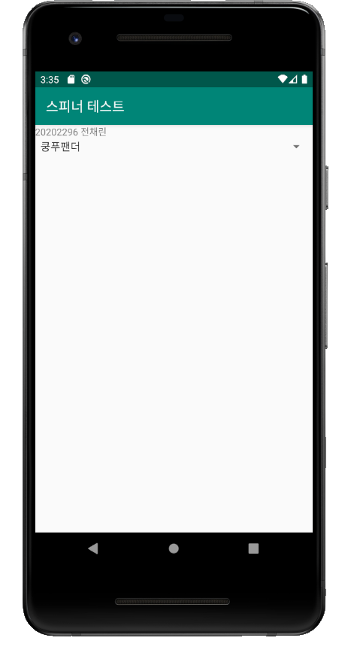

2) 스피너 화면

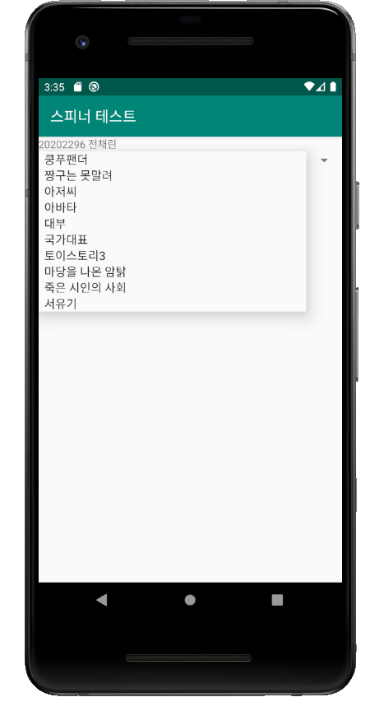

3) 국가대표 선택 화면

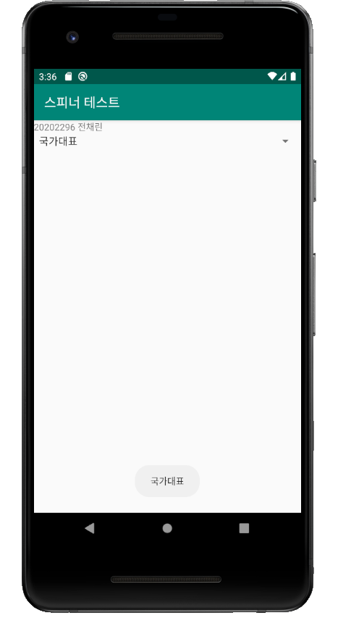

CustomListViewEx

[소스코드]

activity_main.xml

<?xml version="1.0" encoding="utf-8"?>  
<LinearLayout xmlns:android="http://schemas.android.com/apk/res/android"  
 xmlns:app="http://schemas.android.com/apk/res-auto"  
 xmlns:tools="http://schemas.android.com/tools"  
 android:layout_width="match_parent"  
 android:layout_height="match_parent"  
 android:orientation="vertical"  
 tools:context=".MainActivity">  
  
 /* CustomListViewEx  
 activity_main.xml */  
 <TextView  
 android:layout_width="wrap_content"  
 android:layout_height="wrap_content"  
 android:text="20202296 전채린" />  
 <ListView  
 android:layout_width="match_parent"  
 android:layout_height="wrap_content"  
 android:id="@+id/listView1" />  
</LinearLayout>

StudentC.kt

package aca.hankook.customlistviewex  
  
class StudentC(var name : String, var dept : String, var studentId : Int, var sajin : Int) {}

ListViewAdapter.kt

package aca.hankook.customlistviewex  
  
import android.view.View  
import android.view.ViewGroup  
import android.widget.BaseAdapter  
import kotlinx.android.synthetic.main.rowitem.view.*  
  
class ListViewAdapter(var studentList : ArrayList<StudentC>) : BaseAdapter() {  
 override fun getView(p0: Int, p1: View?, p2: ViewGroup?): View {  
 var rowItemView = p1  
  
 if(rowItemView == null) {  
 rowItemView = View.inflate(p2?.*context*, R.layout.*rowitem*, null)  
 }  
  
 val student1 : StudentC = studentList[p0]  
 rowItemView!!.itemImage.setImageResource(student1.sajin)  
 rowItemView.itemName.*text* = student1.name  
 rowItemView.itemDept.*text* = student1.dept  
 rowItemView.itemId.*text* = student1.studentId.toString()  
  
 return rowItemView  
 }  
  
 override fun getItem(p0: Int): Any {  
 return studentList[p0]  
 }  
  
 override fun getItemId(p0: Int): Long {  
 return p0.toLong()  
 }  
  
 override fun getCount(): Int {  
 return studentList.size  
 }  
  
}

MainActivity.kt

package aca.hankook.customlistviewex  
  
import androidx.appcompat.app.AppCompatActivity  
import android.os.Bundle  
import android.widget.Toast  
import kotlinx.android.synthetic.main.activity_main.*  
  
  
class MainActivity : AppCompatActivity() {  
  
 override fun onCreate(savedInstanceState: Bundle?) {  
 super.onCreate(savedInstanceState)  
 setContentView(R.layout.*activity_main*)  
  
 var studentList : ArrayList<StudentC> = *arrayListOf*<StudentC>()  
 studentList.add(StudentC("배수지", "멀티미디어과", 20200001, R.drawable.*suji*))  
 studentList.add(StudentC("한지민", "컴퓨터소프트웨어과", 20200002, R.drawable.*jimin*))  
 studentList.add(StudentC("남주혁", "스타트업과", 20200003, R.drawable.*juhyuk*))  
 studentList.add(StudentC("조정석", "간담췌외과 이익준역", 19990001, R.drawable.*talent1*))  
 studentList.add(StudentC("유연석", "소아외과 안정원역", 19990002, R.drawable.*talent2*))  
 studentList.add(StudentC("정경호", "흉부외과 김준완역", 19990003, R.drawable.*talent3*))  
 studentList.add(StudentC("김대명", "산부인과 양석형역", 19990004, R.drawable.*talent4*))  
 studentList.add(StudentC("전미도", "신경외과 채송화역", 19990005, R.drawable.*talent5*))  
  
 var adapter1 = ListViewAdapter(studentList)  
 listView1.*adapter* = adapter1  
  
 listView1.setOnItemClickListener **{** adapterView, view, i, l **->** Toast.makeText(*applicationContext*, studentList.get(i).name, Toast.*LENGTH_LONG*).show()  
 **}** }  
}

[실행결과]

1) 초기화면

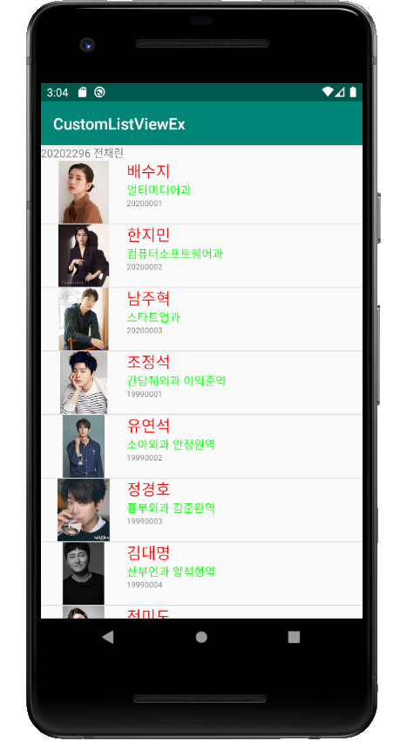

2) 배수지 선택 화면

